**Bahria University, Lahore Campus**

Department of Computer Sciences

Lab Journal 06

**(spring 2022)**

|  |  |  |
| --- | --- | --- |
| Course: | **Data Communication and Networking Lab** | Date: |
| Course Code: | CEL - 222 | Max Marks: 40 |
| Faculty’s Name: |  | Lab Engineer: |

Name: **ALI HASSAN** Enroll No: **03-135211-005**

Objective(s):

To understand the working of switches, router and routing tables.

## Lab Tasks:

**Task 1:** Make Routing Table for R1, R2 and R3 of the topology 1 mentioned in the lab.

**Task 2:** Write the Routing Tables for routers R1 and R2 for the Network Diagram 2.

**Task 3:** Write the Routing Tables for routers R3 and R4 for the Network Diagram 2.

**Lab Grading Sheet :**

|  |  |  |  |
| --- | --- | --- | --- |
| **Task** | **Max Marks** | **Obtained Marks** | **Comments(*if any*)** |
| 1. | 10 |  |  |
| 2. | 10 |  |  |
| 3. | 10 |  |  |
| **Total** | **40** |  | **Signature** |

**Note : Attempt all tasks and get them checked by your Lab. Instructor**

# **Lab 05: Switches, Routers and Routing**

## **Objective**(s):

To understand the working of switches, router and routing tables.

## Tool(s) used:

CISCO Packet Tracer

**Switch:**

A network switch is a [computer-networking device](https://en.wikipedia.org/wiki/Computer_networking_device) that connects devices together on a [computer network](https://en.wikipedia.org/wiki/Computer_network) by using [packet switching](https://en.wikipedia.org/wiki/Packet_switching) to receive, process, and forward data to the destination device.

A network switch is a multiport [network bridge](https://en.wikipedia.org/wiki/Network_bridge) that uses [hardware addresses](https://en.wikipedia.org/wiki/Hardware_address) to process and forward data at the [data link layer](https://en.wikipedia.org/wiki/Data_link_layer) (layer 2) of the [OSI model](https://en.wikipedia.org/wiki/OSI_model). Some switches can also process data at the [network layer](https://en.wikipedia.org/wiki/Network_layer) (layer 3) by additionally incorporating [routing](https://en.wikipedia.org/wiki/Routing) functionality that most commonly uses [IP addresses](https://en.wikipedia.org/wiki/IP_address) to perform [packet forwarding](https://en.wikipedia.org/wiki/Packet_forwarding); such switches are commonly known as layer-3 switches or [multilayer switches](https://en.wikipedia.org/wiki/Multilayer_switch).

**Router:**

A router is a networking device that forwards data packets between computer networks. Routers perform the traffic directing functions on the Internet. A data packet is typically forwarded from one router to another router through the networks that constitute an internetwork until it reaches its destination node.

**What is Routing?**

Routing is the process of moving packets across a network from one host to another host. It is usually performed by dedicated devices called routers. Packets are the fundamental unit of information transport in all modern computer networks, and increasingly in other communications networks as well.

Router Network Diagram shown below.

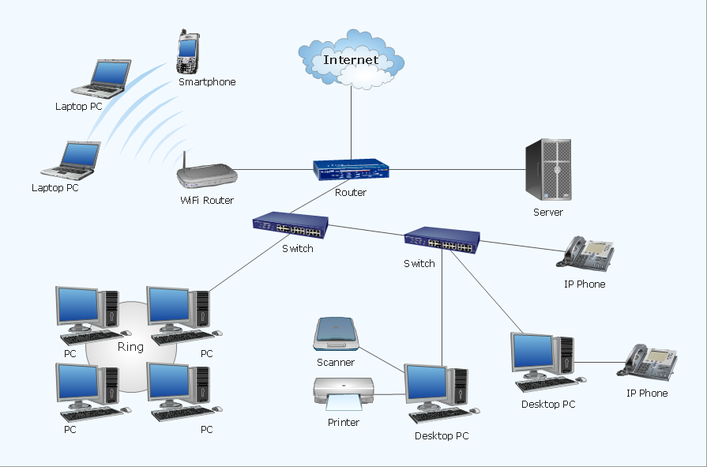

**Static Routing**

Static routing is a form of routing that occurs when a router uses a manually configured routing entry, rather than information from a dynamic routing traffic.

**Task 1:** Write the routing table for the below topology.

**Network Diagram 1**

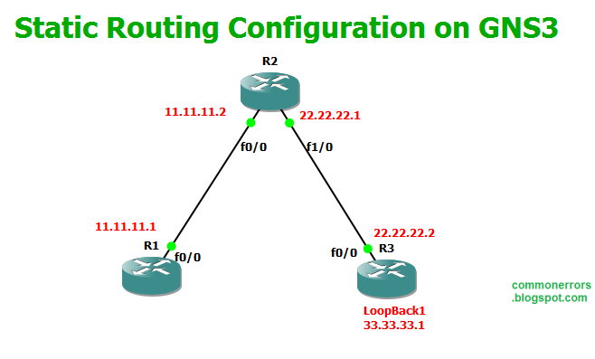

**Routing Table for R1:**

**Routing Table for R2:**

**Routing Table for R3:**

**C: 11.0.0.0 C: 22.0.0.0 C: 22.0.0.0**

**S: 22.0.0.0 via 11.11.11.2 C: 11.0.0.0 C: 33.0.0.0**

**S: 33.0.0.0 via 11.11.11.2 S: 33.0.0.0 via 22.22.22.2 S: 11.0.0.0 via 22.22.22.1**

**Task 2:** Make Routing Table for R1 and R2.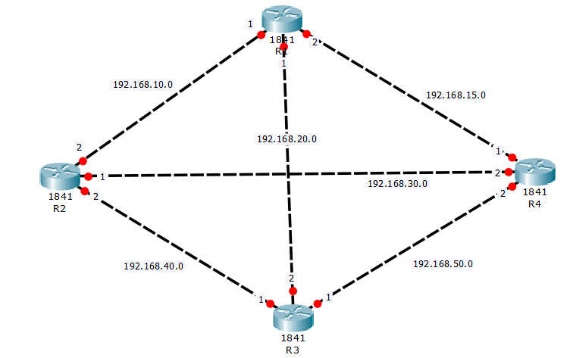

**Routing table (R1) Routing table (R2)**

C: 192.168.10.0 C: 192.168.10.0

C: 192.168.15.0 C: 192.168.40.0

C: 192.168.20.0 C: 192.168.30.0

S: 192.168.50.0 via 192.168.15.1 & 192.168.20.2 S: 192.168.50.0 via 192.168.40.1 & 192.168.30.2

S: 192.168.40.0 via 192.168.10.2 & 192.168.20.2 S: 192.168.15.0 via 192.168.10.1 & 192.168.30.2

S: 192.168.30.0 via 192.168.15.1 & 192.168.10.2 S: 192.168.20.0 via 192.168.10.1 & 192.168.40.1

**Task 3:** Write the routing table for R3 and R4 for Network Diagram 2.

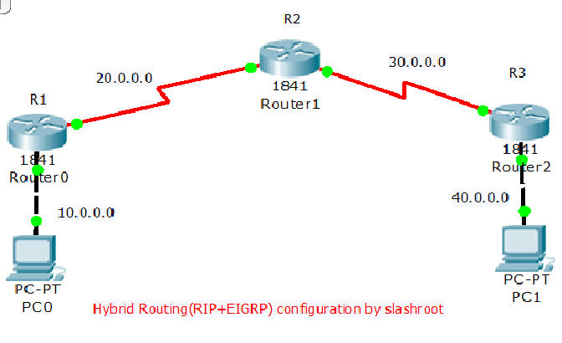

**Routing table (R3) Routing table (R4)**

**C: 30.0.0.0 C: 40.0.0.0**

**C: 40.0.0.0 S: 30.0.0.0 via 40.0.0.2**

**S: 20.0.0.0 via 30.0.0.1 S: 20.0.0.0 via 30.0.0.1**

**S: 10.0.0.0 via 30.0.0.1 S: 10.0.0.0 via 30.0.0.1**